**Description of Understanding of Project**

The goal of this project is to understand how to design and build a website and its services. This project mainly focusses on creation of a complete website which manages and processes web data. The management and fetching of data are done using database. The creation of website requires the knowledge of the following languages: HTML and CSS for appearances and content of the website; JavaScript for validation of the fields; PHP for server-side web development to create dynamic web page content.

The website is going to be created for the organization named LEANEVENTO whose contents are in Spanish. Its **Home Page /Inicio** gives a brief introduction about the organization, what we do and lists all its sponsors. This is the main Home page of this website. It also shows how many volunteers are involved in this organization, the number of people benefited, the number of sponsors and it also quotes Martin Luther King’s words “Injustice anywhere is a threat to justice everywhere”. We can navigate to many pages from the Home page using the links provided on the header of this page such as Aboutus/Quienes Somos, Blog/Blog, Sign Up/Registrate, Contact Us/Contacto, Log In/Iniciar Sesion, Buy from Us/Comprar Boletos. The Home Page does not fetch any table in the database. The contents of this page are static.

Every page in this website has the feature of navigating to any other page provided by the website. This website needs access to three tables in the database: ***User table, Events table and Contact table***.

The **Aboutus/Quienes Somos** page has a detailed description about the organization and its purpose. This page does not fetch any data from the database. The contents of this page are static.

The **Blog** page has various testimonials provided by the volunteers, sponsors and all the people who contributed to this organization. The Blog does not fetch any table in the database. The contents of this page are created by the owners of this website and are static.

The **Sign Up/Registrate** page allows the new users to register to this website. Sign up for a user differs between three types of roles that the organization recognizes: ***Individual, Business and Agent***. For each of these roles, a pop-up is used to receive details from the user. For each of these users, the data received such as Email, Password, Name, Address and City are stored in the ***User table***. For every new user, the database creates a User ID by which each user is recognized uniquely.

Once registered, the user is given a separate account with a **Home** page (***Inicio*** - Home Individual, Home Business, Home Agent) and **Profile** page (***Perfil*** - Individual, Fundacion, Agente) based on the role.

The **Log In/Iniciar Sesion** page allows the users who have already registered with the organization to sign in to their accounts using their username and password. Once the user has signed in to their account, the home and profile pages (as explained earlier) are available to them. The login page is provided with the *Olvido su contraseña* (Forgot your password) link which can be accessed by users who have forgotten their password. Clicking this link will show a pop-up (*Login-recover password/Iniciar Sesion – Recuperar su Contraseña*). This pop-up asks only for the Email ID which was provided by the user during sign up.

***For Individual***, the ***Inicio*** page (Home Individual) contains the list of Events organized, its details, place, date and time and an option to choose between events. The user can choose the event that they are interested in participating and confirm it. The confirmed event is recorded in the database in the ***Events table*** and ***User table***. On confirmation of the event, a pop-up (*Bienvenido*) is displayed to thank the Individual for being a part of that event. These details are updated and fetched from the Events table. The ***Perfil*** page (Profile Home) displays the profile of the Individual with the option to edit all the data provided earlier by the user while creating the account. This profile page fetches data from the User table and displays it.

***For Business***, the ***Inicio*** page (Home Business) contains the list of Events organized and its corresponding details. This page is like the home page of Individual user. The Business user is given the option to choose between the events listed and confirm it. The confirmed event is stored in the database in the *Events table* and *User table*. On confirmation, the *Bienvenido* pop-up is displayed as explained earlier. The ***Perfil*** page (Profile Business) displays the profile of the Foundation whose details were given earlier during the registration of the foundation with the organization. The Business user is given the option to edit or update the details in this page.

***For Agent***, the user has access to create, update and delete events. These details are stored in the ***Events table***. For every event created by the Agent, the database creates an Event ID by which each event is recognized uniquely. The Agent user has the access to add more volunteers as and when needed. Along with these, the agent also has access to add one or more foundations or Business organizations who are interested in participating in various events conducted. All these details are stored in the database in the ***User table***. In short, the Agent acts like an admin who manages the content of this website. To facilitate these responsibilities of the Agent, the following pages are created. *Inicio, Lista de Voluntarios, Lista de Fundaciones, Eventos, Agente*. The ***Inicio*** page (Home Agent LEAN) contains the logo and access to navigate to any other page in the website. ***Lista de Voluntarios*** (List Individual) page displays a list of volunteers or list of Individuals and their corresponding Email, Telephone, Event conducted by them and Responsibility. The details for this page are fetched from the *User table*. ***Lista de Fundaciones*** (List Business) page displays a list of Foundations and their corresponding Events registered, Responsibility, Commission that the Agent gets from the foundation. The details for this page are fetched from the *User table*. ***Eventos*** (Events) page contains the list of Events and its corresponding place and time. The Agent has access to edit the events listed in this page or add a new event and its details as and when required. The details for this page are updated and fetched from the *Events table*. ***Agente*** page is like the profile page of Agent. This page displays the profile along with Agent’s Registration ID and provides an option to edit the data which was provided while creating the account.

The **Contact/Contacto** page displays the contact information of the organization, links to social media profiles such as Facebook, Twitter, Instagram and Email. It also provides a dialog box where a person can contact the organization by providing his/her Email, Name, Topic and the message to be conveyed to the organization. The details entered in this page are updated and stored in the ***Contact table***.

The **Buy from Us/Comprar Boletos** page has links to two pages: Inicio and Comprar Boletos. ***Inicio*** page (Home page) contains the list of events and their ticket value. When the user selects the desired event, it is redirected to the Comprar Boletos page. In ***Comprar Boletos*** page the event is added to the cart. It displays the description of the event, its managers and sponsorships for the event. The details for this page are fetched and stored in the ***Events table***.

**Page and its corresponding tables**

|  |  |  |  |  |
| --- | --- | --- | --- | --- |
| **Page** | **Subpage of Page/Pop-Up** | **Subpage of subpage/Pop-up** | **Its Subpage** | **DB Tables used** |
| Home Page/Inicio |  |  |  | No DB |
| Aboutus/Quienes Somos |  |  |  | No DB |
| Blog |  |  |  | No DB |
| Sign Up/Registrate | Inicio |  |  | No DB |
|  | Registrate | Individual |  | User table |
|  |  | Business |  | User table |
|  |  | Agent LEAN |  | User table |
| Contact/Contacto |  |  |  | Contact table |
| Log In/Iniciar Sesion | Inicio | Home Individual/Inicio | Bienvenido | Events table |
|  |  | Individual/Perfil |  | User table |
|  |  | Home Business/Inicio | Bienvenido | Events table |
|  |  | Fundacion/Perfil |  | User table |
|  |  | Agent LEAN/Inicio |  | No DB |
|  |  | List Individual/Lista de Voluntarios |  | User table and Events table |
|  |  | List Business/Lista de Fundaciones |  | User table and Events table |
|  |  | Events/Eventos | Add Event/Registro | Events table |
|  |  | Agent/Agente- Perfil |  | User table |
|  | Iniciar Sesion | Login-recover password/Recuperar su Contraseña |  | User table |
| Comprar Boletos | Inicio |  |  | Event table |
|  | Comprar Boletos |  |  | Event table |

**Screenshots of DB**

***Database leaneventos with three tables: contact, events, user***

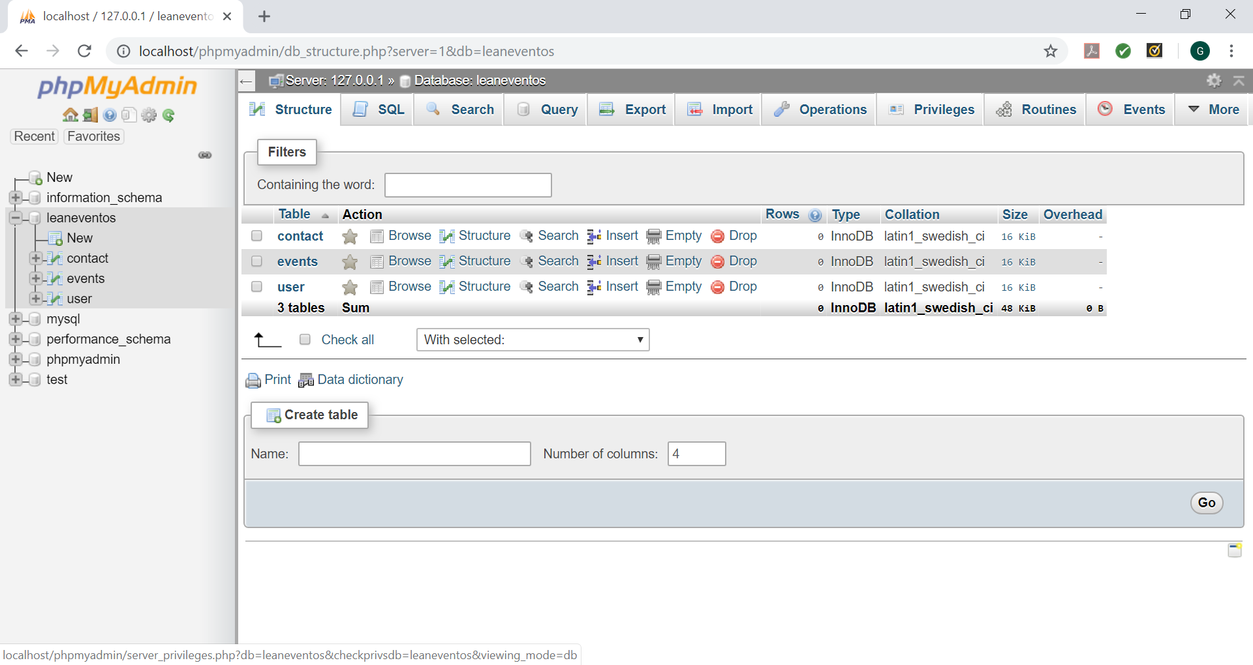

***Contact table***

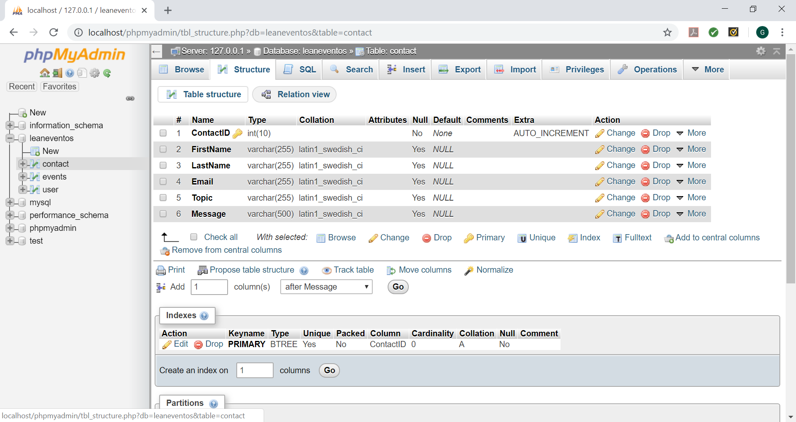

***Events table***

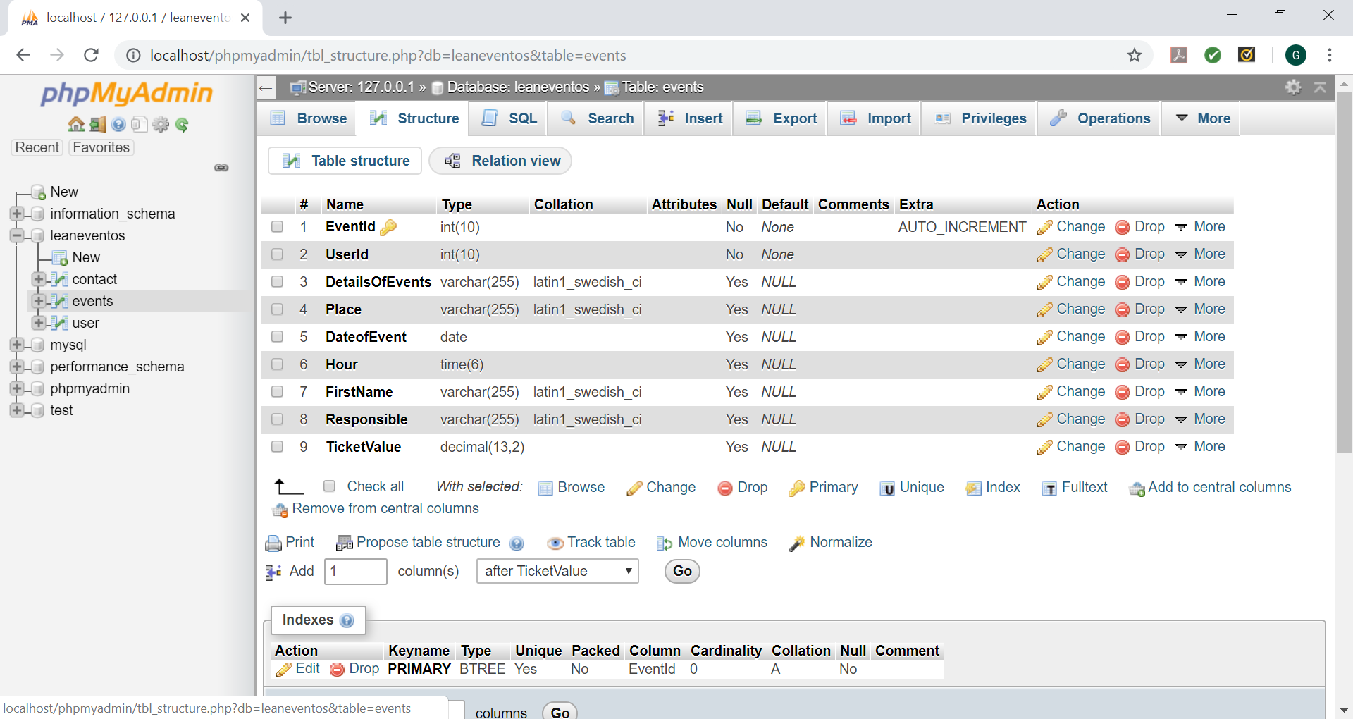

***User table***

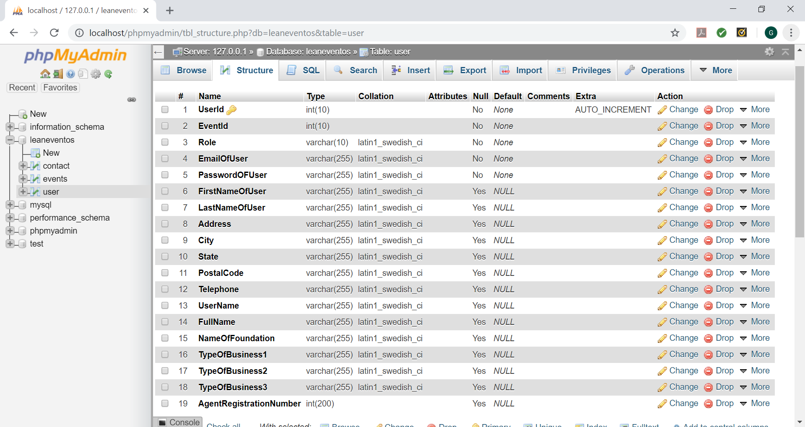

***Populated contact table***

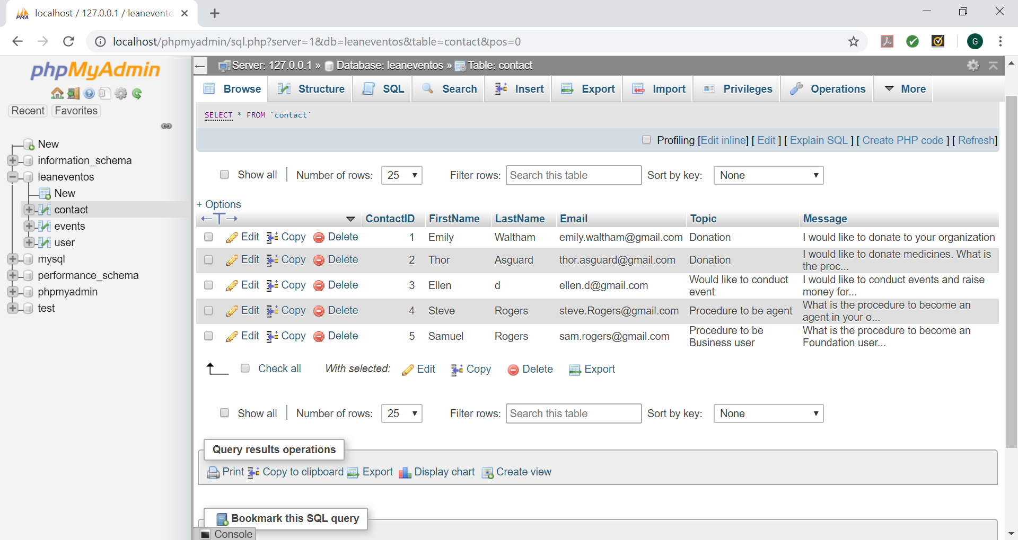

***Populated event table***

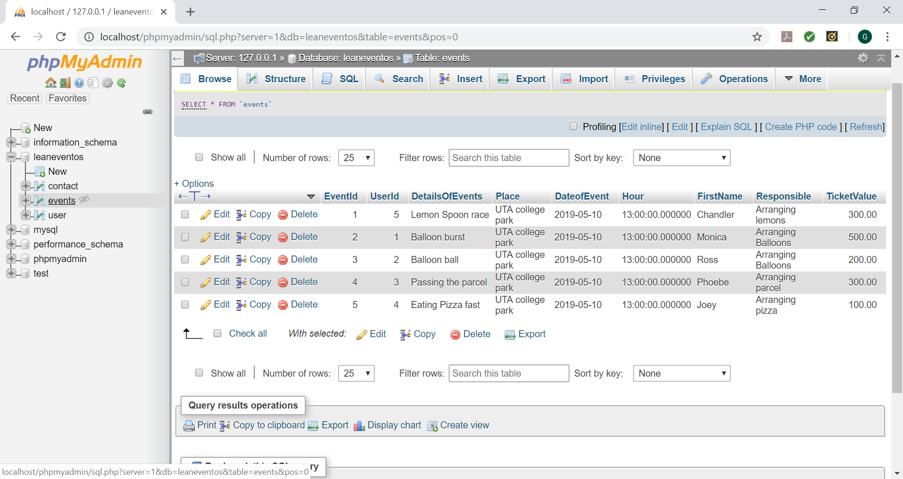

***Populated user table***

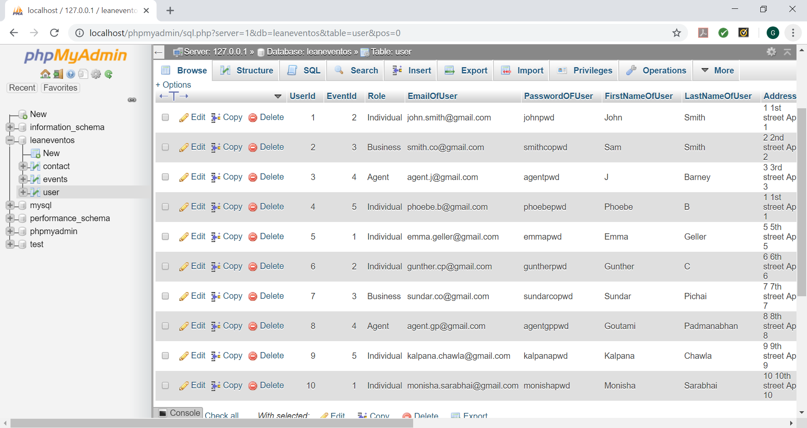

**Database Schema diagram**

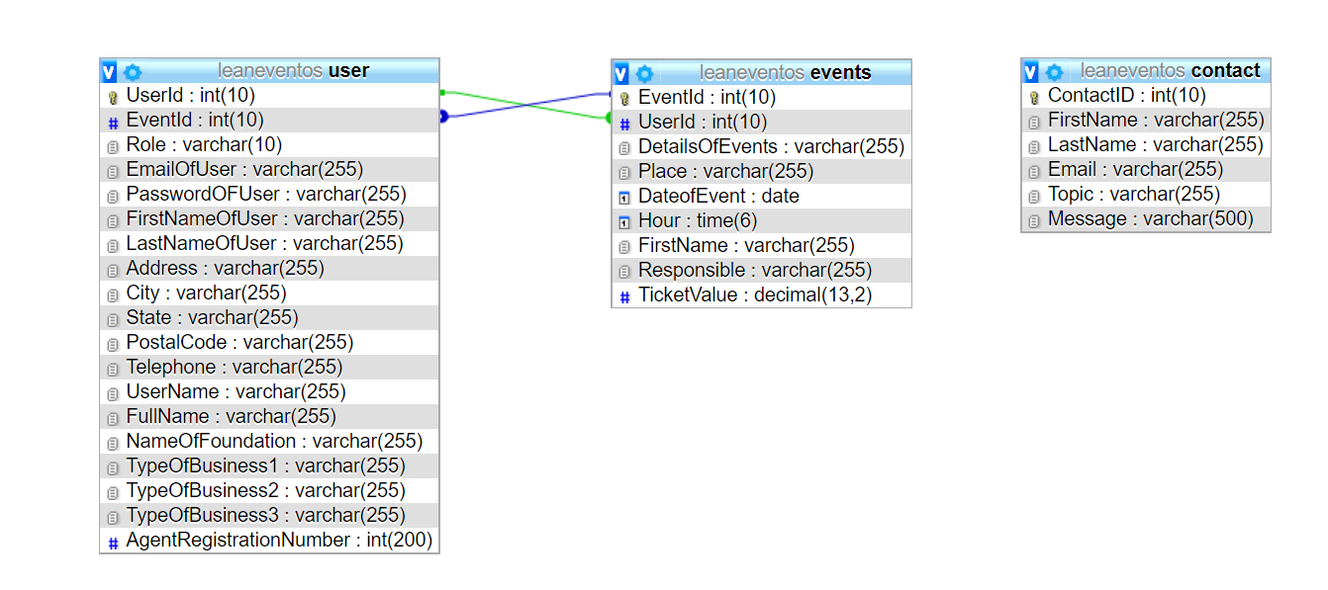

|  |  |  |
| --- | --- | --- |
| Table Name | Primary Key | Foreign Key |
| user | UserID | EventID |
| events | EventID | UserID |
| contact | ContactID |  |